35.8: a) For the number of antinodes we have:
the maximum integer value is four. The angles are
for 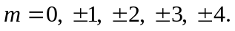
b) The nodes are given by sin 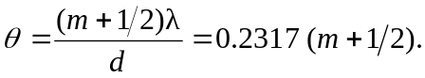So the angles are

